Modular Complex System Brief

Documentation for My Modular Complex System

This is a template to help guide you on writing the brief for your modular complex system. Feel free to edit and modify this as you choose as long as it meets the requirements laid forth in the rubric as defined on Canvas and the Subject and Assessment Guide.

Each section will contain a brief passage of text that describes what you should expect to write. Please remove these passages before submitting your brief for review.

You may amend your modular complex system brief throughout the subject where necessary with discussion with your instructor.

# System Overview

Please provide a brief overview of the modular system that you are creating. This should include the **purpose of the system** that you are created (i.e. what technical need or problem is it solving?).

-RPG battle skills system. Using this tool you will be able to create skills by giving the name, mana cost, type of skill(for example a damage, healing, debuff/buff), choose its range of effect or have it be single target, pick a max level.

# Packaging

Please describe how your program will be packaged for delivery for use by others.

This can come in one or many forms which is up to your choosing:

* C#
  + A set of C# source files
  + A class library (.dll file)

# Quick Start – Using the Modular Complex System

## Integrating the System

Please list and describe each step that a fellow programmer would have to bring your complex system into their own program or even another library.

You should be able to provide these instructions to someone unfamiliar to your project but has enough technical knowledge to be familiar with the overall process.

## Building Upon the System

Please describe how a fellow programmer could build on your system in order to use your modular complex system.

For example, your system may provide a base type to inherit from in order for other programmers to provide additional logic that is tailored for their game.

-This system would allow programmers to create their own custom skills for their RPG game with ease

# Underlying Mathematical Operations and Algorithms

## Mathematical Operations

Please list and explain the reason for any notable **mathematical operations** that your modular complex system will need to undertake. The use of vector math alone is not notable – it is very common in game development to make use of vectors.

For example, it is notable and worth mentioning that your project will calculation *barycentric coordinates* to create a software renderer that will interpolate values for use in its fragment shader stage.

-not sure

## Advanced Algorithms

Additionally, please list and explain the reason for any notable **advanced algorithms** that your modular complex system will need to undertake.

For example, it is notable and worth mentioning that your program will implement *behavior trees* as a part of creating a robust set of designer-friendly tools for authoring behavior trees.

-not sure

# Additional Third-Party Libraries

Please identify and provide a link and license for each third-party library used to implement this modular complex system.

When discussing each third-party library, discuss why it is included rather being completely implemented by yourself.

# Research Material

Optionally, please include links or references to other research material that helped you develop this modular complex system.

Appendix I – Technical Design

# Technical Requirements

The technical requirements are the needs that must be met for your project to perform as required (i.e. meet the needs of the client or user of your modular complex system).

* Target Frame Rate
  + You may choose to vary this in different situations (i.e. 60fps gameplay, 30fps cutscenes)
    - 60fps
* Target Render Resolution
  + You may specify more than one, if applicable
  + This should serve as the baseline for how you author your user interface
  + Omit this if rendering is uninvolved
* Memory Usage Budget
  + Please specify if any memory will need to be dynamically allocated (and deleted/GC’d)
* Target Device and/or Hardware
  + If specifying a PC, please provide an approximation of the capabilities of the PC.
    - Should be able work on low spec PCs

# Technical Design

The technical design of a project is a provides a high-level understanding of how your project will be engineered to meet the requirements laid out above.

* Major Systems and/or Data Types
  + (Please provide a highly level description of how the systems or data types interact with each other)
    - Should be able to call create a skill by calling a function and giving it the necessary parameters
    - Can call a function that will increase skill level
    - Can call a function that changes a specified skill
* Global and/or Persistent State
  + Global Variables
    - Type, damage, name, range, max level, current level, exp
* Unity (if applicable)
  + Scripting Runtime
  + Render Pipeline
  + Tags and Layers
    - Might need tags something like that to help know what gameobjects will be targeted by skill

## Class Diagram

**Optionally**, you may choose to include a class diagram to show how you plan to create this system.

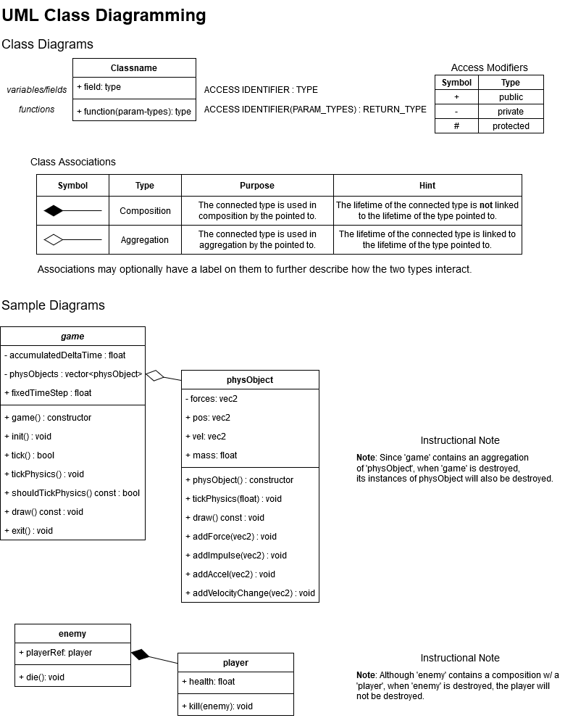

The above diagram was created using <draw.io> in “Class Diagram” mode. Elements for things like the “composition” and “aggregation” associations can be found in the element palette in the bottom-left corner of the interface.

# Technical Risks

If there any risks or further considerations that provide cause for concern, please list them here.

# Credits

Trey Gleason © 2022